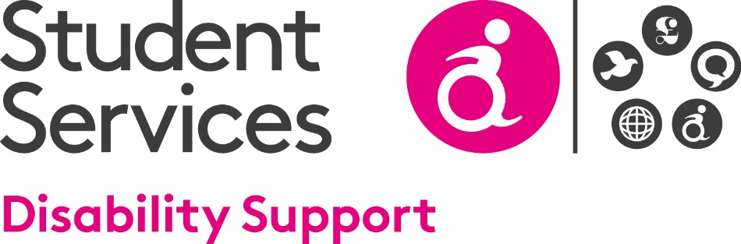

Support Request Form

The Disability Service at the University of the West of Scotland offers support and advice to any student who has a disability or specific learning difficulty, for example, Dyslexia. A disability is a physical or mental impairment that has a significant negative, long-term effect on your ability to do normal daily activities. Long-term means a condition that has lasted or is likely to last 12 months or more.
Please complete this form only if you have, or think you may have, a disability and would like an appointment to discuss support. The information given in this form is confidential.

You are advised to register with the Disability Service as soon as possible in order to ensure that individual arrangements to support you through your studies can be discussed with a Disability Adviser.

An electronic version of this form is available on request from disabilityservice@uws.ac.uk.

Further information can also be found on our website: www.uws.ac.uk/disabilityservice

Your Contact Details
Banner Number:
Name:
Date of Birth:
Mobile Number:
Email Address:

Campus of Study:
Please tell us about the nature of your disability:

To ensure your safety we need to know if you have difficulty evacuating a building in the event of a fire (e.g. a hearing impairment prevents you from hearing the fire alarm). Please tell us about this:

If you have had support at school/college/university previously please tell us about the support you received:

Please return this form, as soon as possible:

In Person: The Student Hub or Student Link on your campus
By Post: Disability Service, University of the West of Scotland, High Street, Paisley, PA1 2BE
By Email: disabilityservice@uws.ac.uk

